Setting up new iPads from the box
Last updated 12/5/13 ios7.0.4
Required materials
Download iTunes from the computer that will manage the ipads. http://www.apple.com/itunes/download/
Make sure you have a label maker handy
You will need access to Microsoft Excel
iPad and sync cable
Contact ITS to get the correct iTunes account information. Ext 1013 or 1033
Access to the computer you will be syncing the iPads to.
_____________________________________________________________
Things to consider: Who will manage apps on the iPads? How will you keep them secure?
This guide is intended for iOS7 the may be a few variations
Naming Convention: The iPad naming convention we use is: SchoolAbbreviation_UniqueName_”iPad”_Numberof iPad
Example: SLELAIPAD01
Unboxing-Labeling-Inventory. When you receive a bulk box of iPads each iPad will have its own cardboard box with the serial number on the outside. It is easiest to inventory them now since the serial number is very small and difficult to read on the device. Create a new Microsoft Excel spreadsheet and create columns for Location, Name, Serial Number, Model, and assigned.
Take one device out of the box and inventory it. Record the required information in your spreadsheet (name, serial number, and model, location, assigned). Next use your label maker to create a label with the naming schema you have chosen. Please make sure the labels have a good adhesive so they are not easily removed.
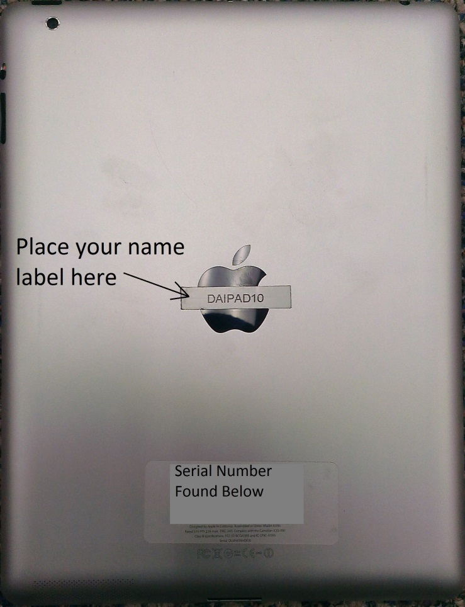

Conditional. If your case does not provide easy access to reveal the name label you should create an additional label to attach to the case or use a paint pen to write the name. This will make things easier when identifying devices.
Place the label on the back of the ipad in the middle where the apple logo is and repeat the process until all of the ipads have been labeled and inventoried.
Please send a copy of your inventory to suracer@eht.k12.nj.us

Install iTunes. Now install iTunes from the setup you downloaded from http://www.apple.com/itunes/download/.
Accept all of the default prompts

Once iTunes is installed you can now start setting up your ipads
You will need to create a master iPad backup. Although this is a lengthy process you will only have to set one iPad up this way.
Take one ipad to be the master and power it on.
Click next until you come to the “Choose wifi Network” screen and select EHT-Wireless.
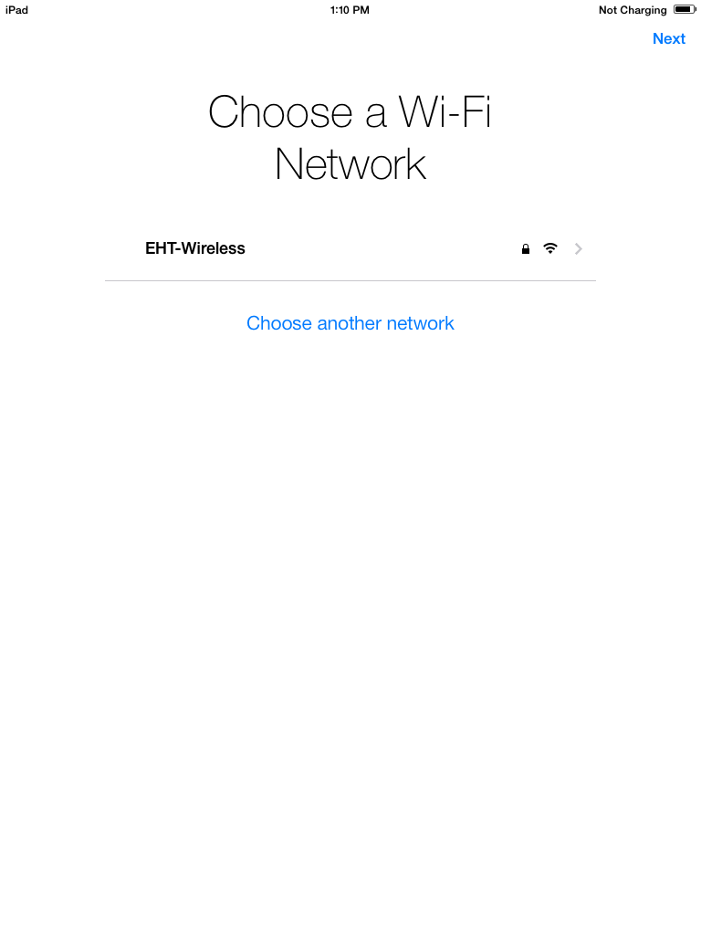

Next you will need to authenticate using your Novell username and password. (The username and password you use to log in to your computer)

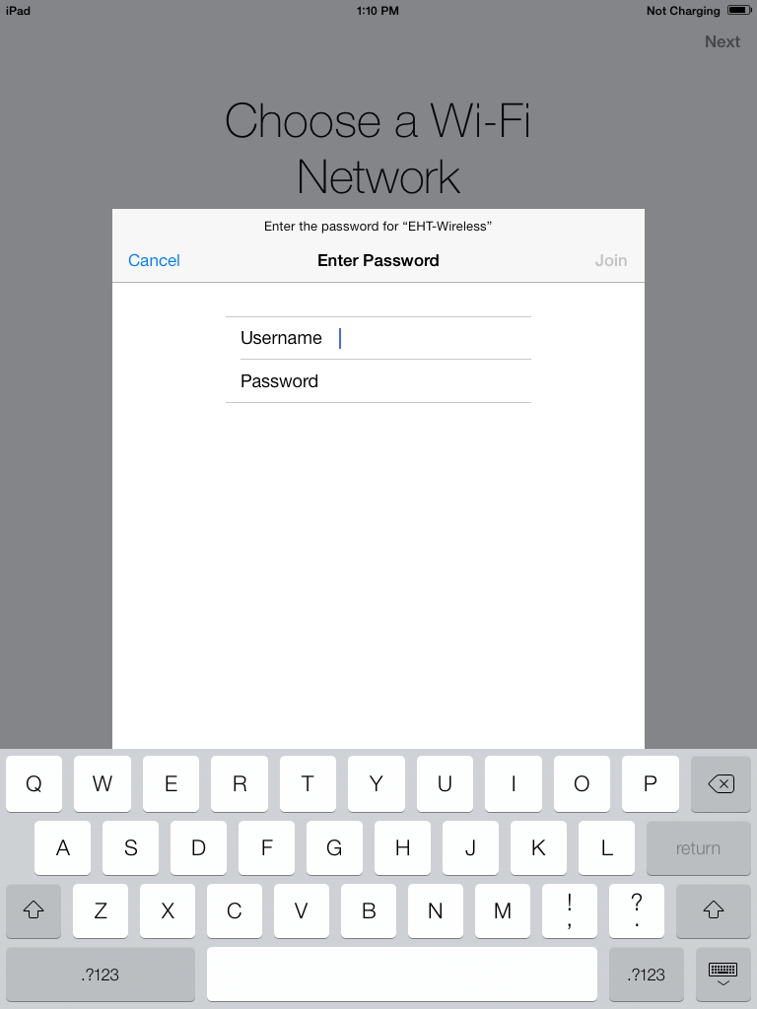

Next accept the radius certificate
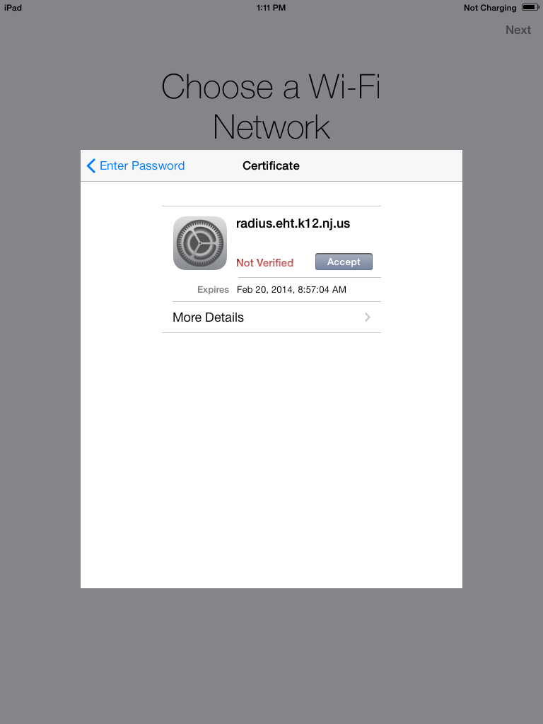

Next click cancel for location services for now

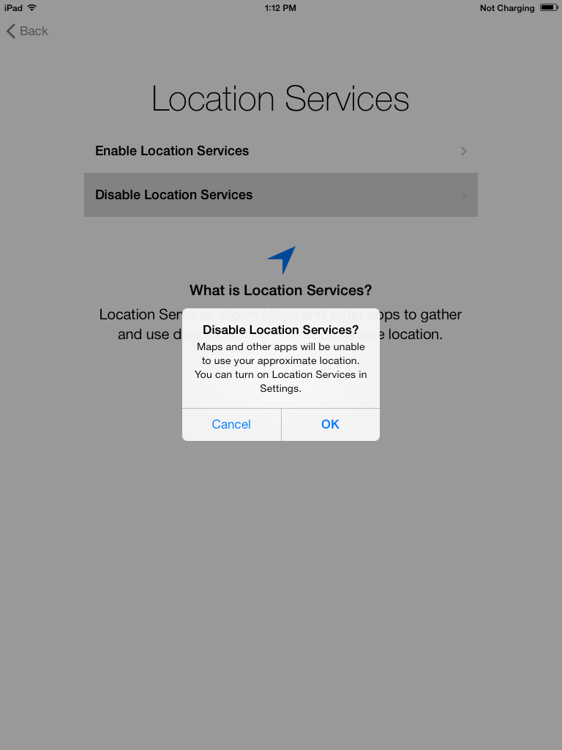

Select “Set Up as New iPad”
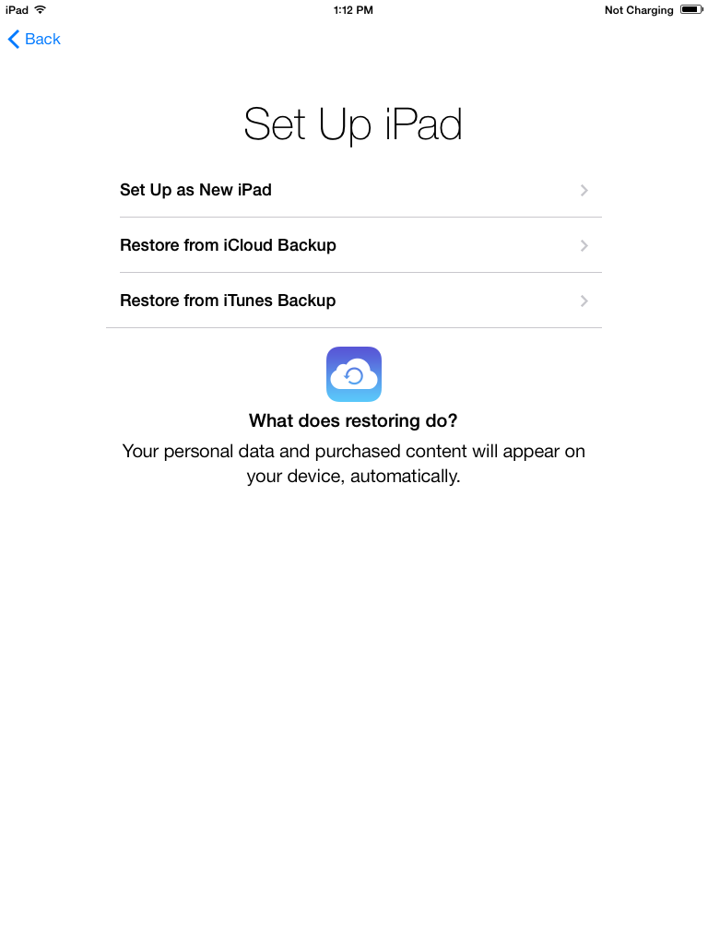

You will now enter the credentials you were supplied with for the iTunes account you will use
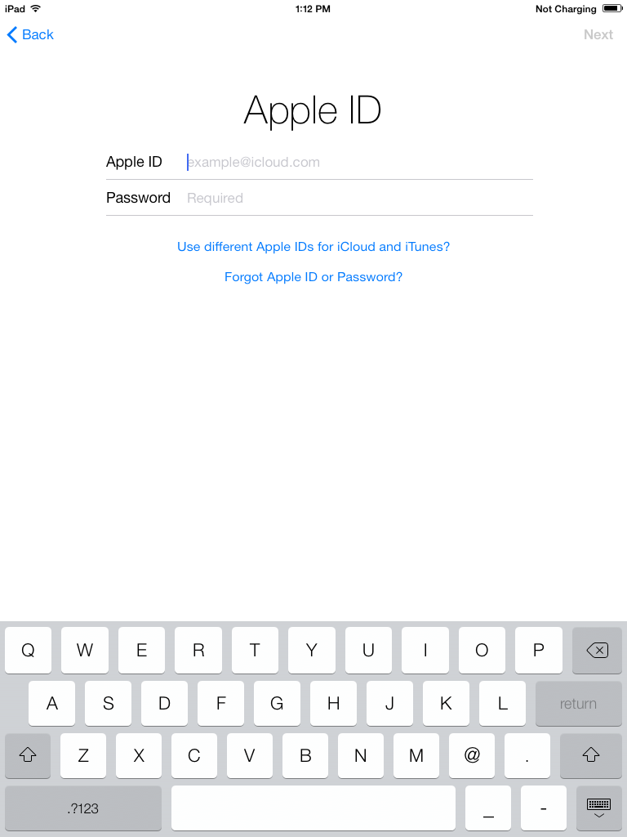

Agree to the terms and conditions
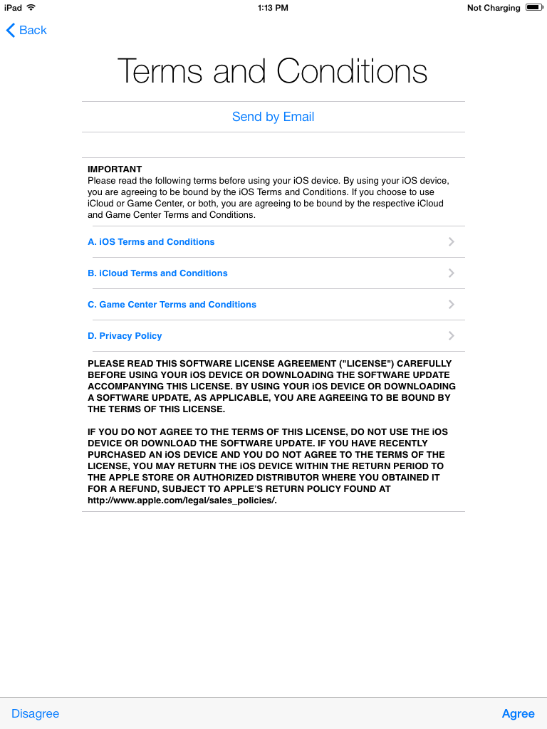

When asked to create a passcode look toward the bottom of the screen and tap “Don’t Add Passcode”
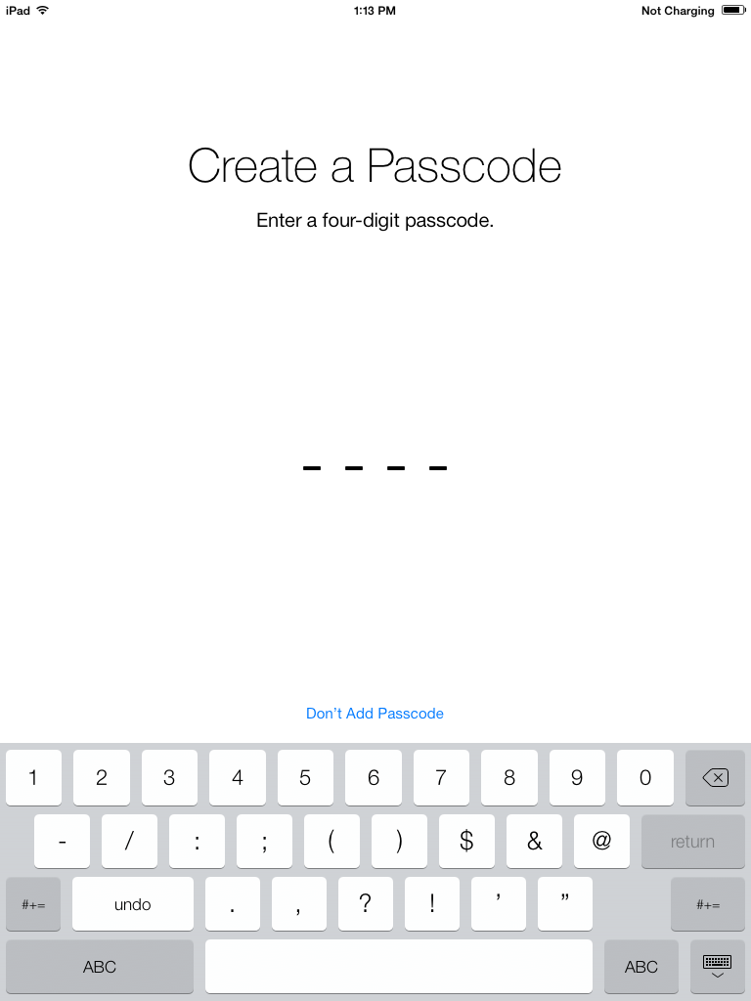

Tap “Don’t Send” for the diagnostics screen

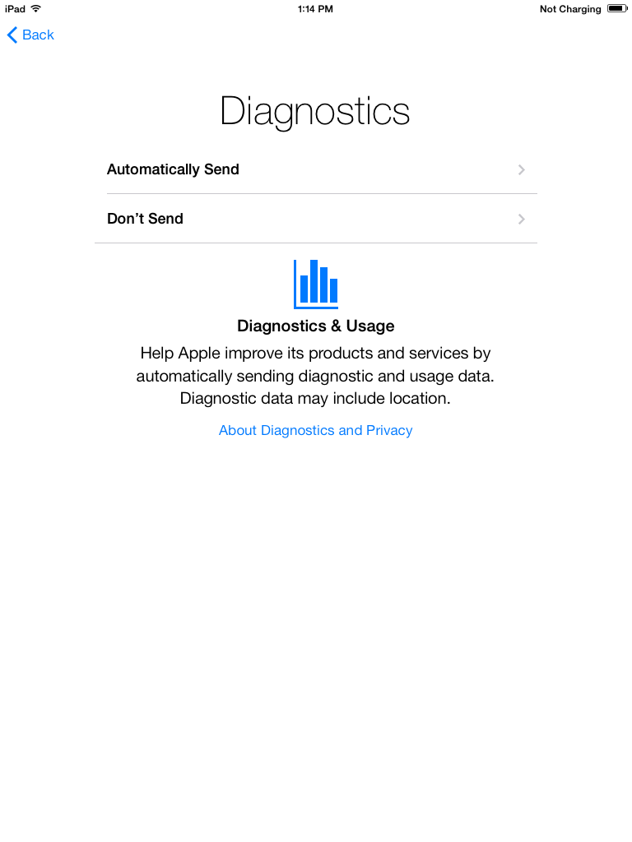

Next click “Get Started”
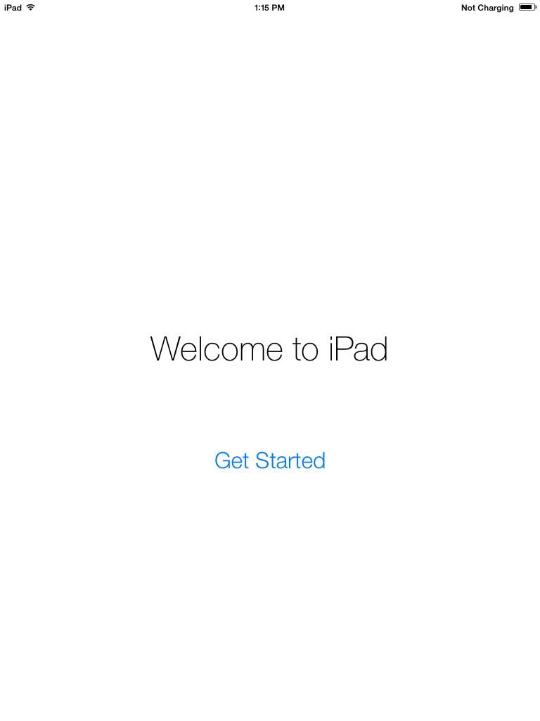

Open the Safari App and enter your Novell credentials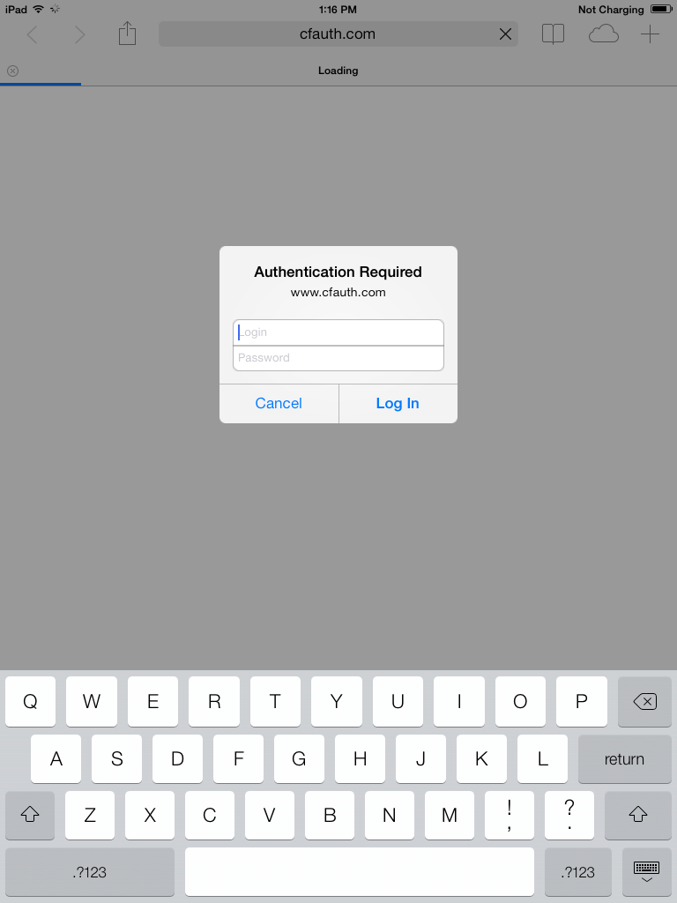
Next tap continue
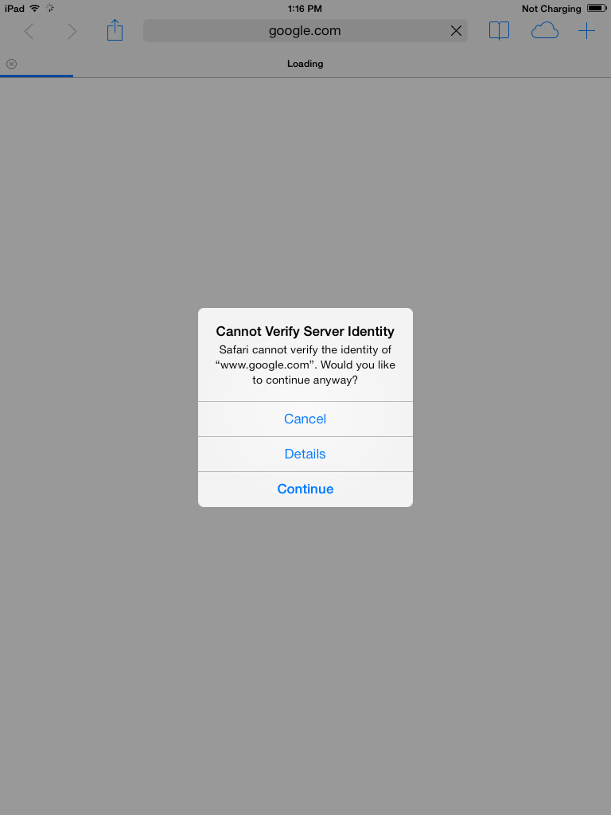

You should now have access to the internet
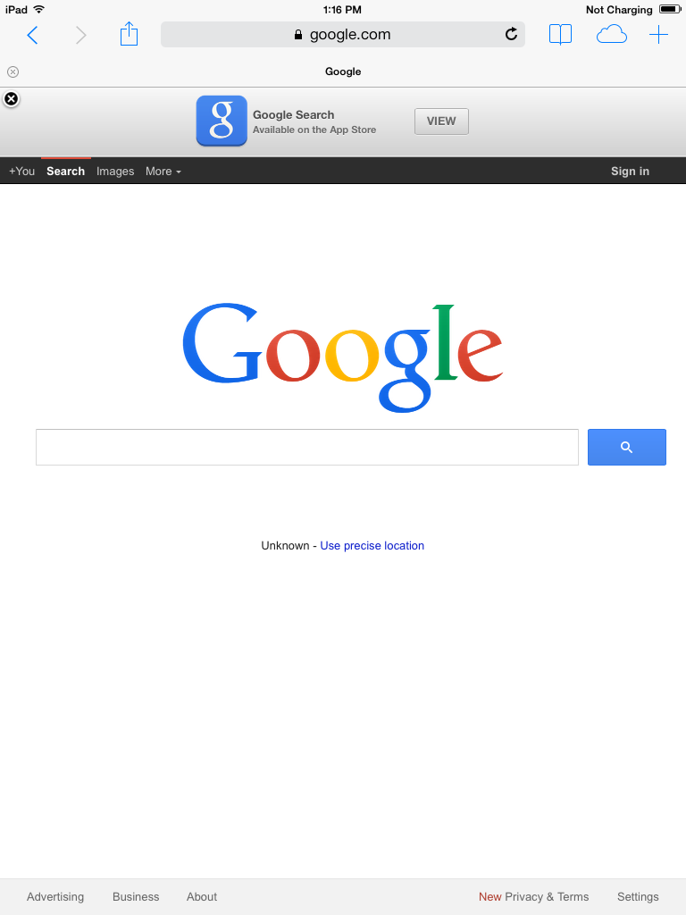

Click on the Home button to return to the Home screen
Tap on the Settings App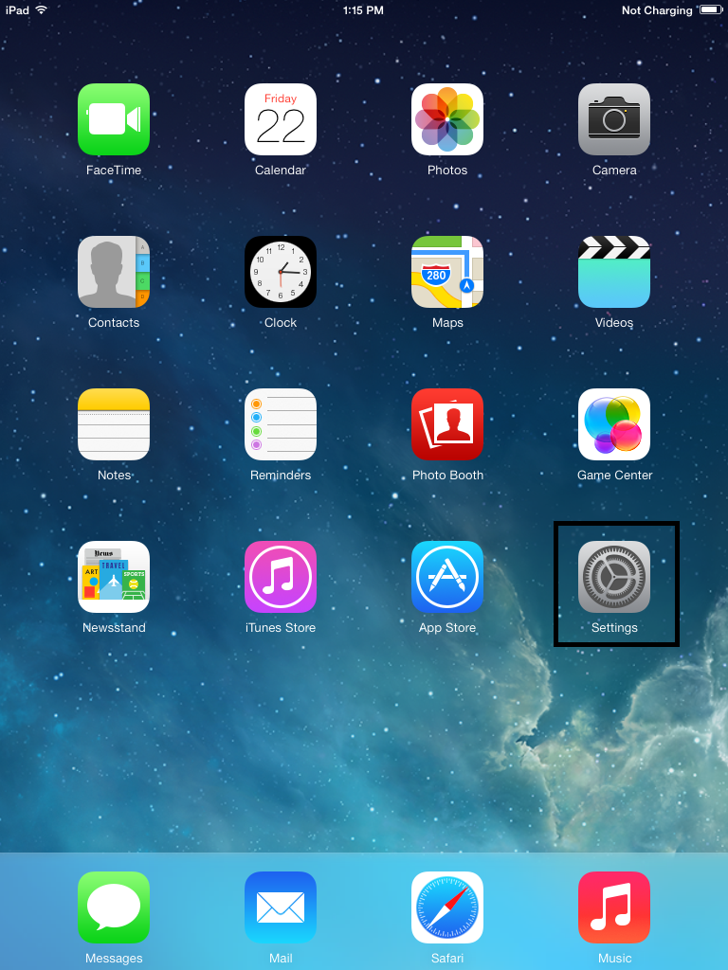

Disable Bluetooth. This will save battery life
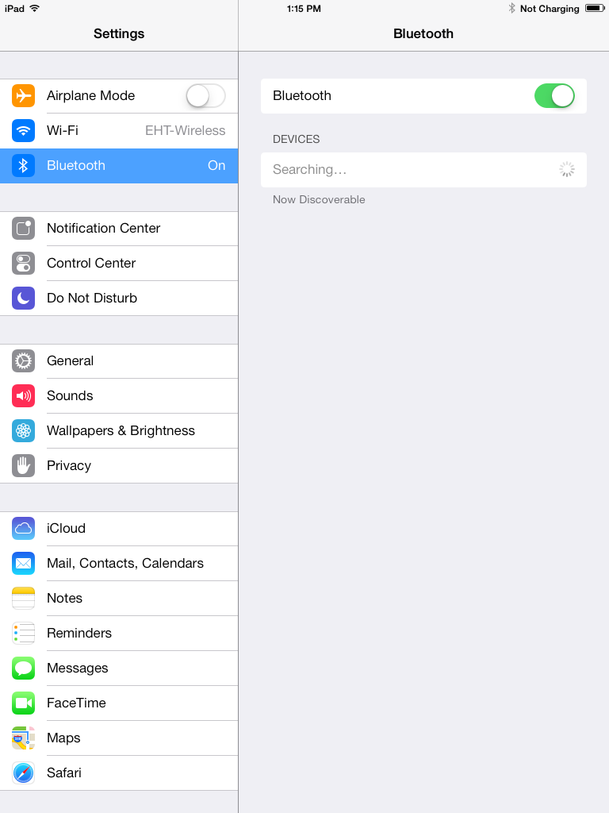

Go to the iTunes & App Store section. If your apple id (iTunes account) is not there add it now. Make sure automatic downloads for Music and Apps is off
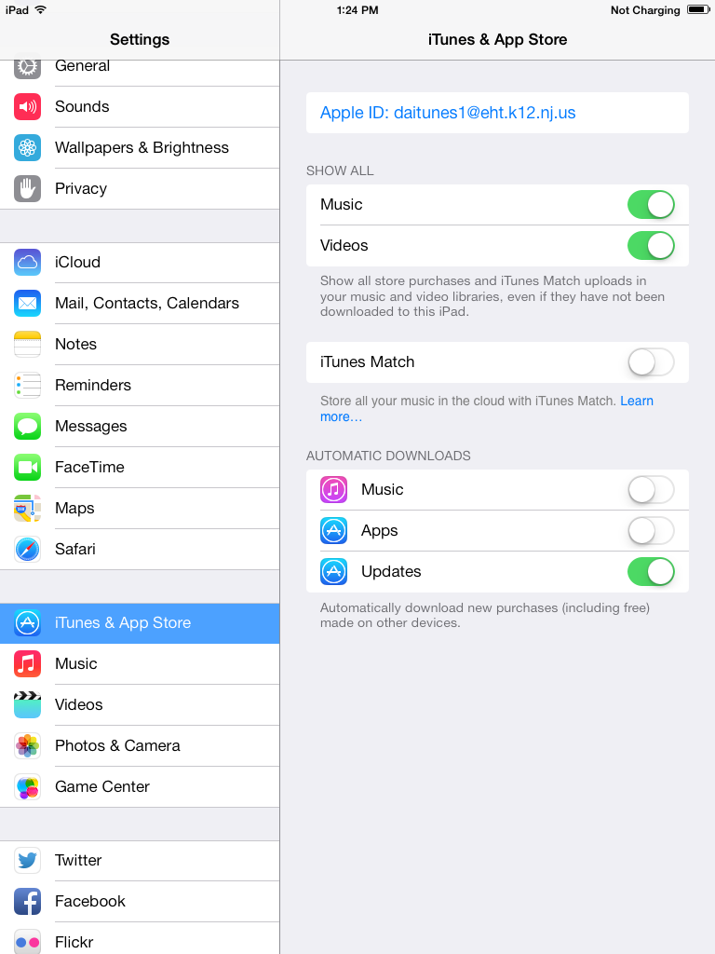

Now go down to Mail, Contacts, and Calendars
Turn off everything besides Find My iPad
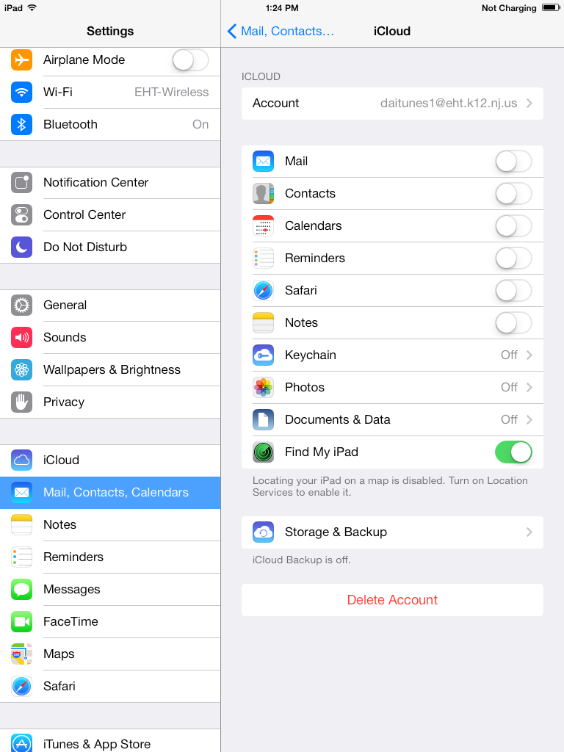

Next go to Photos and Camera and make sure my photo stream and photo sharing are turned off.
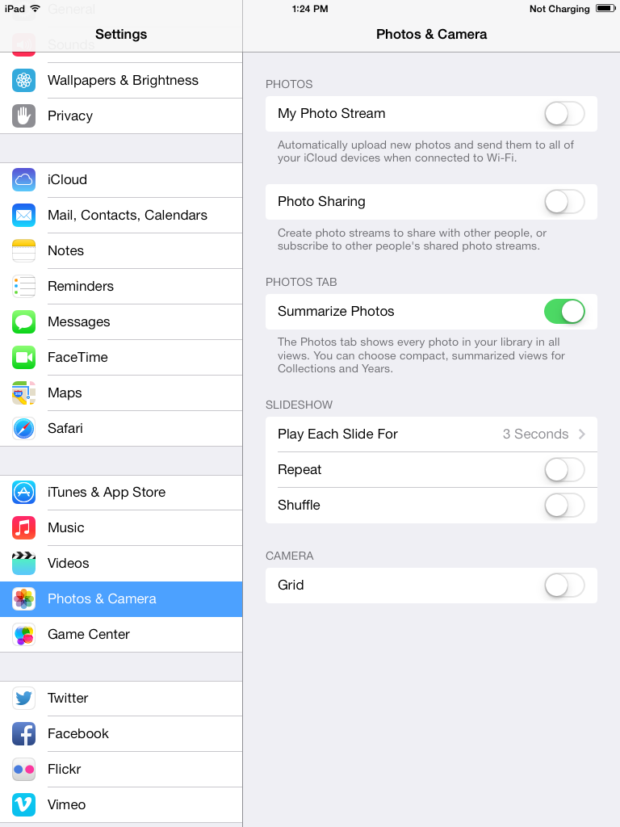

Next go to the general section in settings
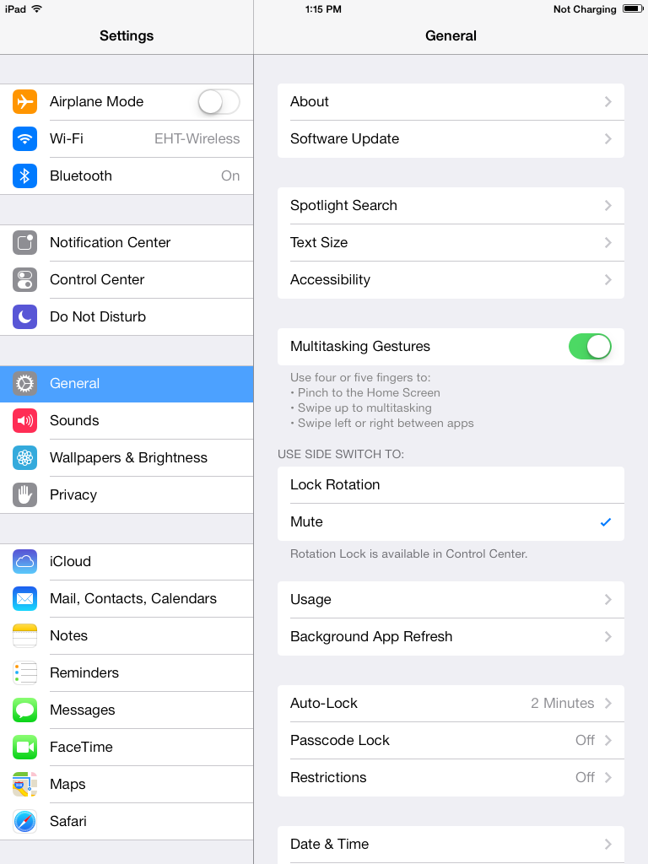

Tap on Restrictions and add the passcode you received from the ITS department

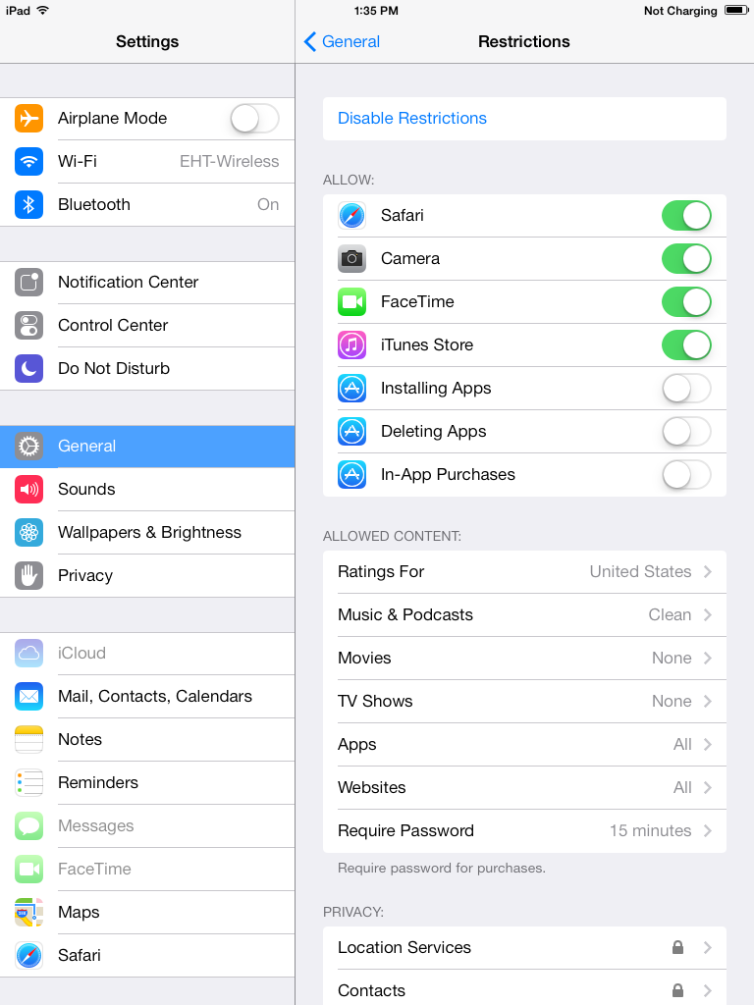
Make sure the following are disabled
Face time
Installing Apps
Deleting Apps
In-App Purchases
Music and Podcasts: clean
Movies: None
TV Shows None
Location Services: Don’t allow Changes
Contacts: Don’t allow Changes
Calendars: Don’t allow Changes
Reminders: Don’t allow Changes
Photos: Don’t allow Changes
Bluetooth Sharing: Don’t allow Changes
Twitter: Don’t allow Changes
Facebook: Don’t allow Changes
Advertising: Don’t allow Changes
Accounts: Don’t allow Changes
Background App Refresh: Don’t allow Changes
In game center turn off Multiplayer Games and Adding Friends

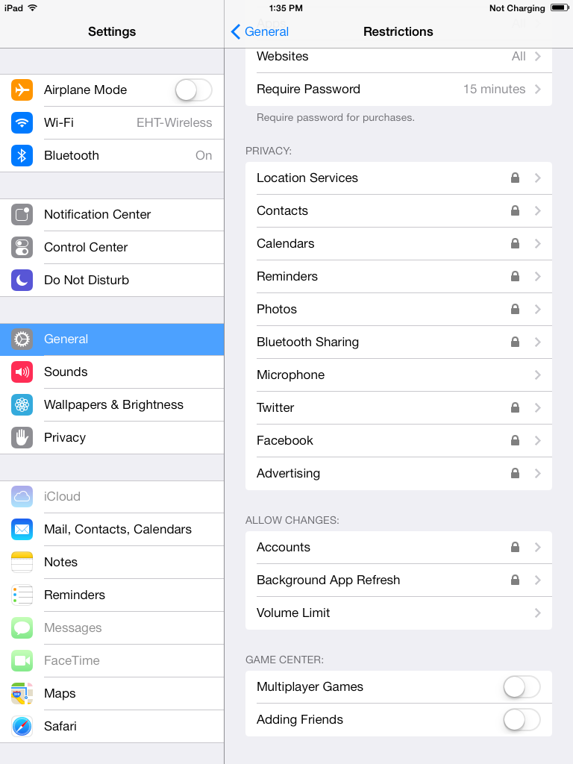

Once the Master iPad is prepped you need to plug it into your computer and open iTunes.

First you need to show the sidebar. You do this by pressing ctrl and s at the same time. ctrl + s
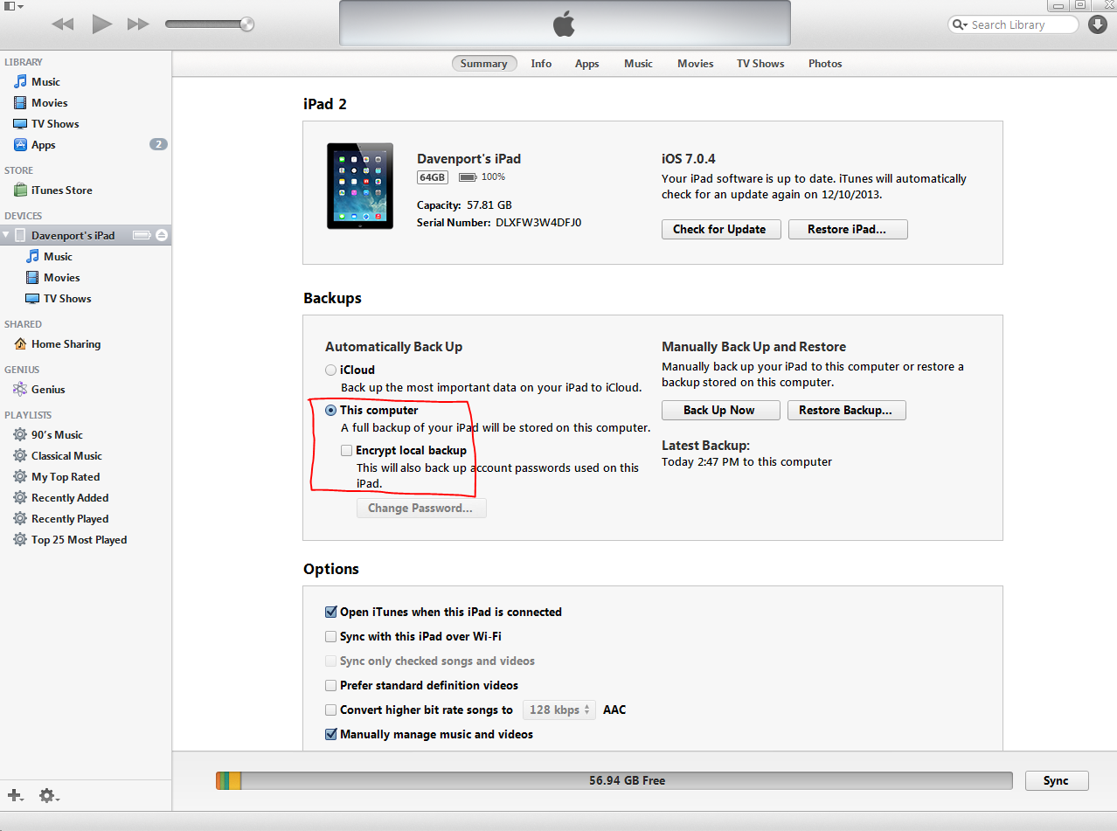
Now you can see the devices on the sidebar to the left
Select your device on the sidebar and make sure to check “This computer” and “Encrypt local backup” is checked. The password you will use is the same as the iTunes password.

We need to download one free app from the appstore.
Type “Dictionary” in the search bar then click “Free” below the Dictionary.com iPad app.
This will download the app into your app library.
If iTunes asks for your username and password enter your given iTunes credentials
Note: you need to type the full email address for the iTunes username
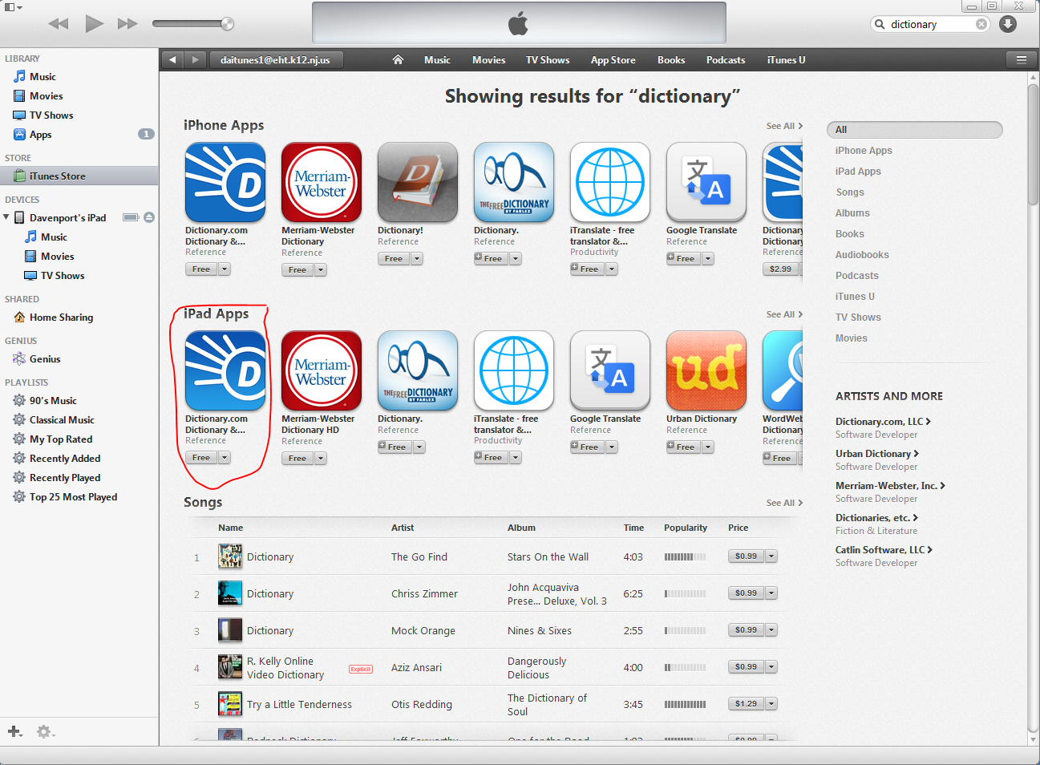

Now go back to your iPad on the side bar then select “Apps” Now select “Install” for the Dictionary app and check “Automatically install new apps”
This will make it easier when you set up the other iPads
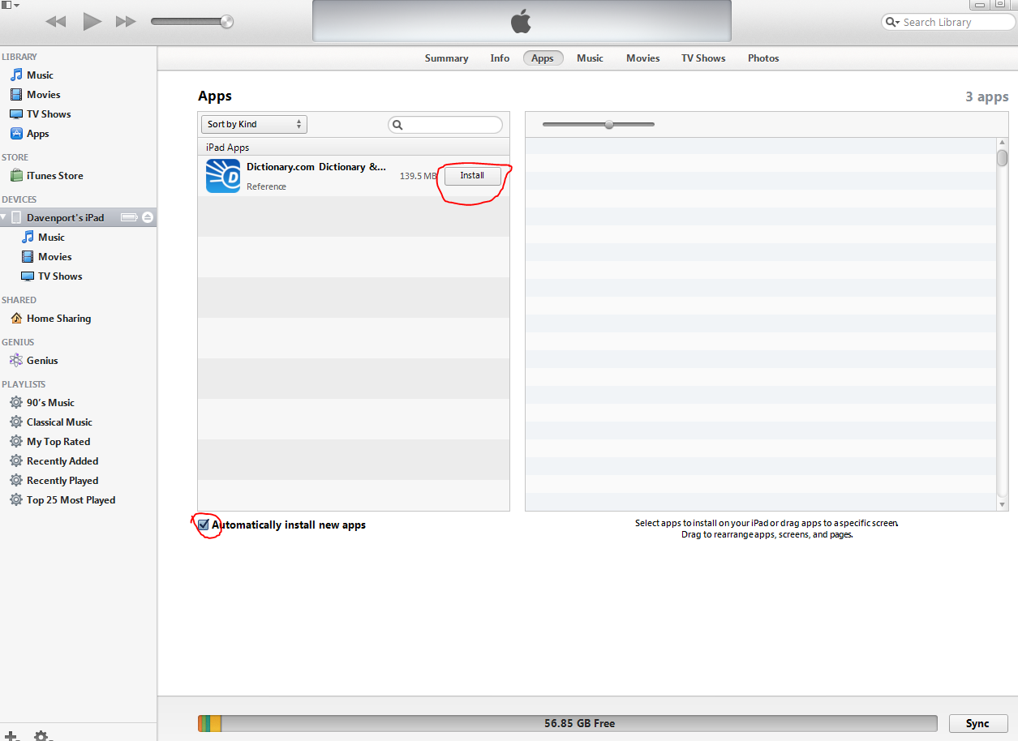
Click sync when finished
Go back to the summary section of the iPad

Now take backup
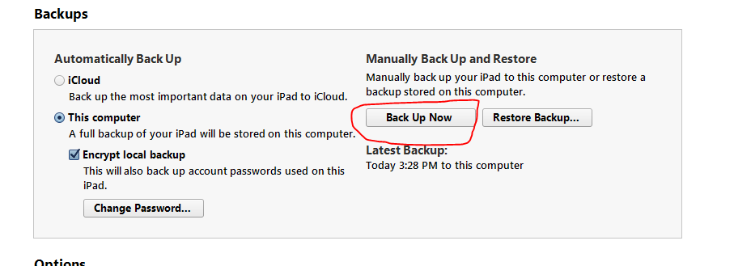

Now that your backup is done you are now ready to restore the rest of your ipads
Plug in the next iPad (ipad number 2) Choose Restore Backup
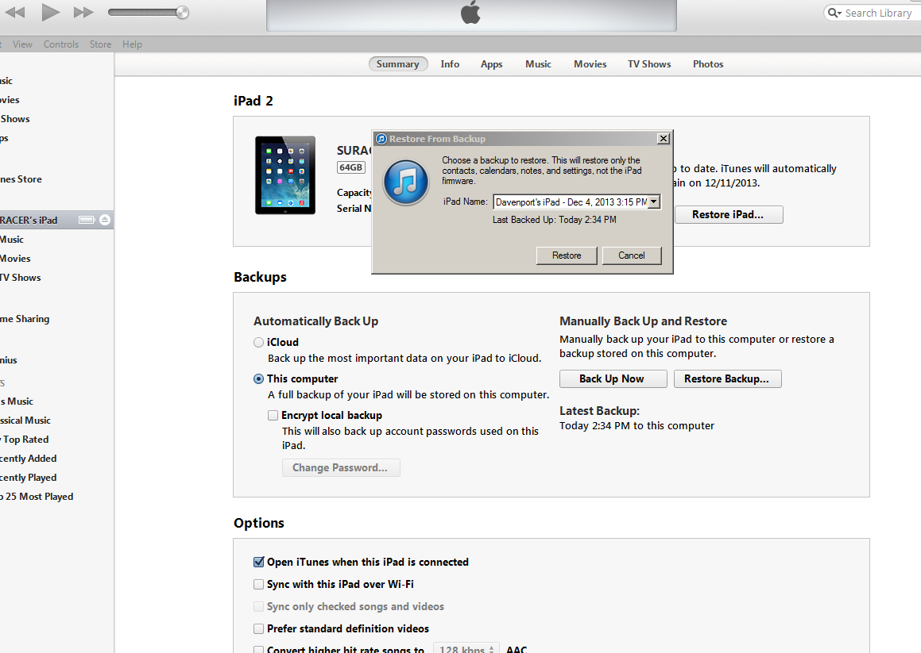
Choose the backup you just created and click Restore
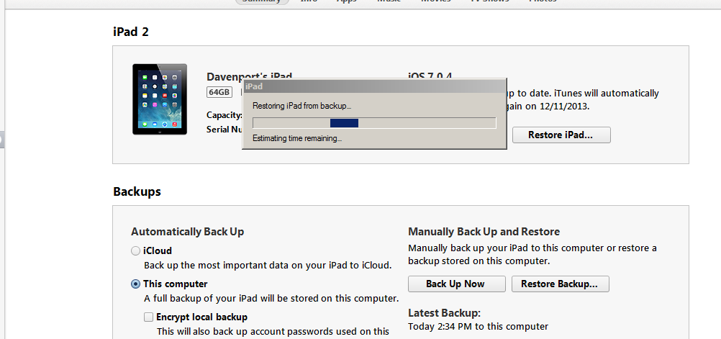

Now rename the iPad to what you labeled it by clicking on the name on the sidebar.
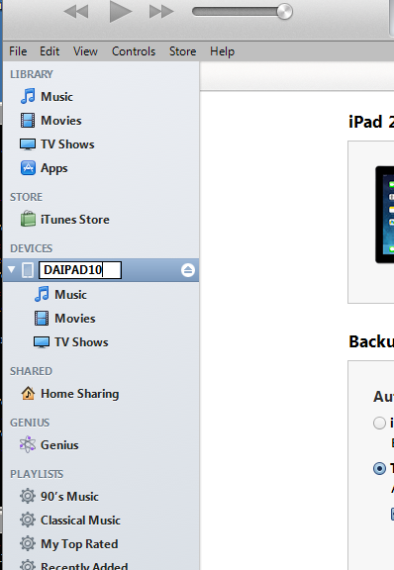

Now click sync and your ipad will sync the apps that are in your app library.
Repeat this process for the remaining ipads.
What you will end up with is identical iPads besides the name.

